9*10W LED PAR WATERPROOF
USER MANUAL

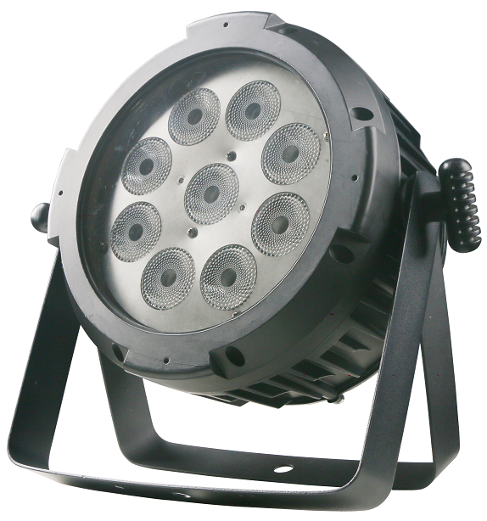

MHL-281B

Please read and keep this manual carefully for further use!

Thank you for buying our professional Beam moving head.
This user manual includes important information for installation and operation, so please read this user manual carefully before installation and operation, and keep this user manual well for further use.
In order to install , operate, and maintain the lighting safety and correctly. We suggest that the installation and operation should be done by the verified technician and follow the instruction strictly.
Spare part includes:
Name | QTY | Unit
Fixture | 1 | PC
User manual | 1 | PC
Power cable | 1 | PC
DMX cable | 1 | PCS
Handle | 1 | PC

Please check carefully that there is no damage caused by transportation. Should there be any, consult your local dealer.
Cautions
Before delivery, this device has passed strict inspection, Please follow the user manual strictly for operation, if this fixture is damaged by improper operation and mistake, the fixture will be out of warranty, and manufacture or dealer won’t be responsible for it. In case of any technology change in this manual,we won’t advise in further .



CAUTION!

Keep this device away from rain and moisture!

Unplug mains lead before opening the housing!

Warning!

Silkscreen symbol on light
Damages caused by the disregard of this user manual are not subject to warranty. The dealer will not accept liability for any resulting defects or problems.

Installation
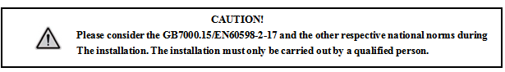

► This fixture is not suitable for direct installation on combustible material surface, please keep the fixture surface at least 0.5m from any combustible material.

► If you use the quick lock cam in hanging up the fixture, please make sure the quick lock fasteners turned in the quick lock holes correctly.
►The applicable temperature for the fixture is between -25°C to 45°C. Do not use the lighting under or above this temperature range.
►The truss for hanging the fixture should be able to hold 10 times weight of this fixture and no deformation after 1 hour hang.
►Please don’t stand under the fixture when install, uninstall, move or repair the fixture.
►Please ensure the light is connected correctly and invite professional technician to check and confirm the electrical data before installation.
►Please invite professional technician to check the fixture and installation each year.
Rigging：

Insert the quick-lock fasteners of the first holder into the respective holes on the bottom of the device.Tighten the quick-lock fasteners fully clockwise.
Fix the clamp on truss or other fixture bracket.
Pull the safety rope through the holes on the bottom of the base and fasten it on the truss or other fixing point.
Note:This step is quite important to ensure that fixture will not drop down for the clamp damage.

Product specification

Voltage：100-240V，50/60HZ；
Power Consumption：120W；
LED: 9*10W RGBWA-UV 6in1 LED
Average lifespan: 50,000 hours
LED adopts static constant current driving mode, with high constant current precision; the light source can be dimmed individually, with 256-level brightness, no flicker;
DMX Channel: 10/6 CH
Control mode: DMX512/Master-slave/Auto/Sound/ panel menu control
New optical design and high brightness of glass lens
Strobe:1-23HZ or random strobe
Electrical dimming：0%~100%
DMX Connector: 3-pin XLR input/output
Working temperature: -10º~45º

Display and operation
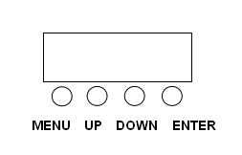

Key button | Function
MENU | Function selection
UP | parameter increase
DOWN | parameter decrease
ENTER | Save, confirm

Setting:

A001-A512 | 10CH mode | Refer to the 10CH table
d001-d512 | 6CH mode | Refer to the 6CH tablel
CJ01-DJ16 | Jump change
CF01-CF16 | Gradient change
CC01-CC16 | Pulse change
SOUD | Sound control
CL01-CL32 | Color Selection | Refer to the Color Selection table
R000-R255 | Red brightness
G000-G255 | Green brightness
B000-B255 | Blue brightness
W000-W255 | White brightness
P000-P255 | Purple brightness
o000-o255 | Orange brightness

10 DMX channel
10CH | Function | Value | Description
1 | Dimming | 0-255 | Dimming 0-100%
2 | Red | 0-255 | Red 0-100%
3 | Green | 0-255 | Green 0-100%
4 | Blue | 0-255 | Blue 0-100%
5 | White | 0-255 | White 0-100%
6 | Purple | 0-255 | Purple 0-100%
7 | Orange | 0-255 | Orange 0-100%
8 | Strobe | 0-255 | Strobe from slow to fast
9 | Macro | 0-49 | No effect
9 | Macro | 50-99 | Jump change
9 | Macro | 100-149 | Gradient change
9 | Macro | 150-199 | Pulse change
9 | Macro | 200-255 | Sound control
10 | Speed | 0-255 | Macro speed: slow to fast
6 DMX channel
6CH | Function | Value | Description
1 | Red | 0-255 | Red 0-100%
2 | Green | 0-255 | Green 0-100%
3 | Blue | 0-255 | Blue 0-100%
4 | White | 0-255 | White 0-100%
5 | Purple | 0-255 | Purple 0-100%
6 | Orange | 0-255 | Orange 0-100%

Color Selection Table
CL1 | R
CL2 | G
CL3 | B
CL4 | W
CL5 | P
CL6 | O
CL7 | RG
CL8 | GB
CL9 | RB
CL10 | RGB
CL11 | RW
CL12 | GW
CL13 | BW
CL14 | RGW
CL15 | GBW
CL16 | RBW
CL17 | RGBW
CL18 | RP
CL19 | GP
CL20 | BP
CL21 | RGP
CL22 | GBP
CL23 | RBP
CL24 | RGBWP
CL25 | RO
CL26 | GO
CL27 | BO
CL28 | RGO
CL29 | GBO
CL30 | RBO
CL31 | RGBO
CL32 | RGBWPO
DMX-512 connection

Connect the provided XLR cable to the male 3-pin XLR output of your controller and the other side to the female 3-pin XLR input of the light.then connect the DMX signal to the first fixture to the 2nd fixture, after all fixtures are connected,

The signal cable should be two - core with screened cable with XLR input and output connectors. Please refer to the diagram below

DMX terminator connection
If there are many lines or lights, it is recommended to use a DMX terminator to prevent DMX signal corruption, the DMX terminator is an simple XLR plug with a 120 Ω resistor connected between pins 2 and 3,which is then plugged into the output XLR socket of the last fixture in the chain.
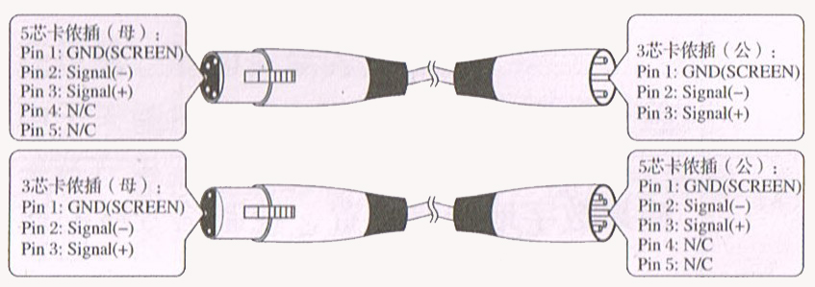
3-Pins connection
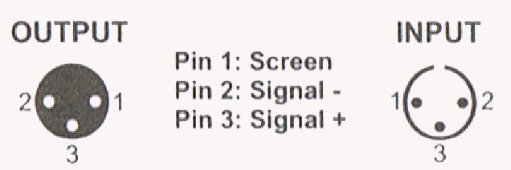

Cleaning and maintenance

Cleaning should be performed every 15-day period, by using a sponge which is dipped with alcohol, rather than wet cloth or other chemical liquid, to clean the mirror.

Cut off power before cleaning and maintenance!
CAUTION

Attention

Do not see directly light source when open the light, and make sure power off before do any installation or maintenance.


 Wires connection must be done professional person!
CAUTION

Cautions
Before delivery, this device has passed strict inspection, Please follow the user manual strictly for operation, if this fixture is damaged by improper operation and mistake, the fixture will be out of warranty, and manufacture or dealer won’t be responsible for it. In case of any technology change in this manual,we won’t advise in further .

Warranty Card
This product is made of high-brightness transistor. We will provide 1 year warranty under the condition that user has operated the light normally and lifetime service. We won't provide warranty if the damage is caused by artificial or force majeure event. Cost of fittings should be charged by user if product need maintenance after 1 year .Please cut this warranty card and shipped it along with the product to our factory when applying for warranty.
Product：
Purchasing date：
Code of invoice：
Warranty date: From To
User’s name： Add：
Company： Tel：

